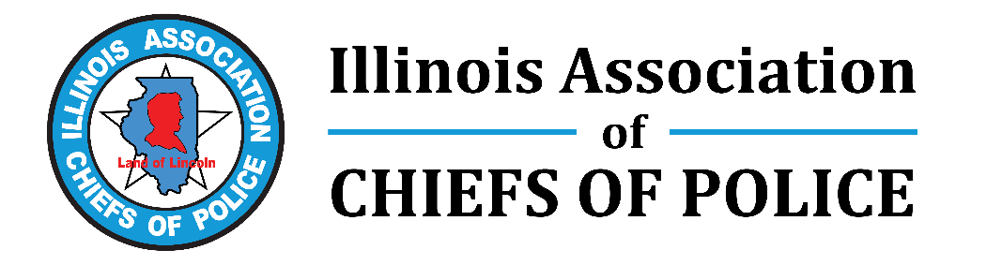
ACTION ALERT on HB 5452 – Talking Points for ILACP Members

“Support the drone bill to give law enforcement an important tool”

August 9, 2022

- ACTION ALERT:

  - Contact your state reps and senators NOW – in August 2022 – and tell them it’s a priority to get HB 5452 passed this fall, whether in a special session or veto session.
  - Share with them the attached FACT SHEET.
  - Tell them Illinois law needs to be changed to allow law enforcement to have common-sense ways to deploy drones at events. Waiting until something happens is too late!
- This bill will make it easier for law enforcement to use drones, especially at community events, while still protecting people’s privacy and civil rights.
- For law enforcement, a drone (technically called an unmanned aerial vehicle):
  - Is a force multiplier, adding to other tools now utilized
  - Allows for real-time, unobtrusive intelligence at events such as parades, concerts, and festivals
  - Is a much more common device now used by citizens, hobbyists, Realtors, inspectors of bridges, and much more
- Why we need this bill: Law enforcement can use drones to photograph accident scenes and crime scenes, to search for missing persons, and after an emergency is under way, but cannot proactively observe a community event such as a concert or parade.
The Highland Park incident on July 4 is a clear example where law enforcement and the entire community may have benefited from more common-sense language in state law.
- Ironically, helicopters with cameras are now allowed, but not drones, which are far less expensive and far easier to deploy.
- Types of events and incidents where the law would allow LE to have real-time intelligence:
Cars dashing into crowds, people on rooftops, parades, festivals, concerts.
- Examples of incidents where proactive use of drones, if allowed in Illinois, would have been helpful in possibly preventing a mass incident or reducing its negative impact: the Las Vegas concert shooting, the Waukesha parade, the Houston concert trampling

